# Empathy Map - Public Transport Management System

**Project Name**: Transport Management System

**Date**: 22 June 2025

**Team ID**:  LTVIP2025TMID30883

**Target User**: Airline Passenger / Airline Staff

## Empathy Map

|  |  |
| --- | --- |
| Says | “I want a simple way to assign drivers and conductors to trips.”  “I need to fetch ticket fares quickly based on the route and bus model.”  “I hate checking Excel sheets or paper records manually for every trip.” |
| Thinks | “Will the trip data be validated properly before dispatch?”  “Is the ticket fare assigned correctly for this bus and route?”  “Will I get accurate reports on employee assignments by station?” |
| Does | Creates and manages trips in Salesforce  Assigns buses, drivers, and conductors using lookup fields  Checks ticket fare data using automated flows  Runs reports like "Employees by Bus Station" |
| Feels | Worried about assigning the wrong person to a trip  Anxious if the fare logic isn’t applied correctly  Frustrated with delays caused by manual validations or missing data |

**🚌 Public Transport Management System**

📄 Project Name: Public Transport Management System  
📅 Date: 22 June 2025  
🆔 Team ID: LTVIP2025TMID30999

🔹 Problem Statement 1:  
I am a dispatcher or admin  
I’m trying to create and manage trips, assign drivers and conductors, and apply fare rules efficiently  
But the existing system is manual, scattered across Excel sheets, or lacks validation logic  
Because it does not enforce role-based assignment or dynamic fare calculation  
Which makes me feel uncertain, causes operational delays, and increases the chance of human errors

🔹 Problem Statement 2:  
I am a station manager  
I’m trying to track employee distribution across bus stations and generate reports easily  
But without a centralized system, data entry is inconsistent and reporting is tedious  
Because legacy systems do not offer grouped or filtered reports dynamically  
Which makes me feel frustrated and dependent on external support for even simple overviews

| **Field** | **Response** |
| --- | --- |
| **I am** | An Admin |
| **I’m trying to** | Create trips, assign drivers & conductors, and apply fare rules accurately and efficiently |
| **But** | The current system is manual, prone to errors, and lacks role validation or automation |
| **Because** | There is no integration between trip, fare, and employee assignment modules |
| **Which makes me feel** | Frustrated and unsure if the trip is assigned correctly or if fare logic is applied properly |

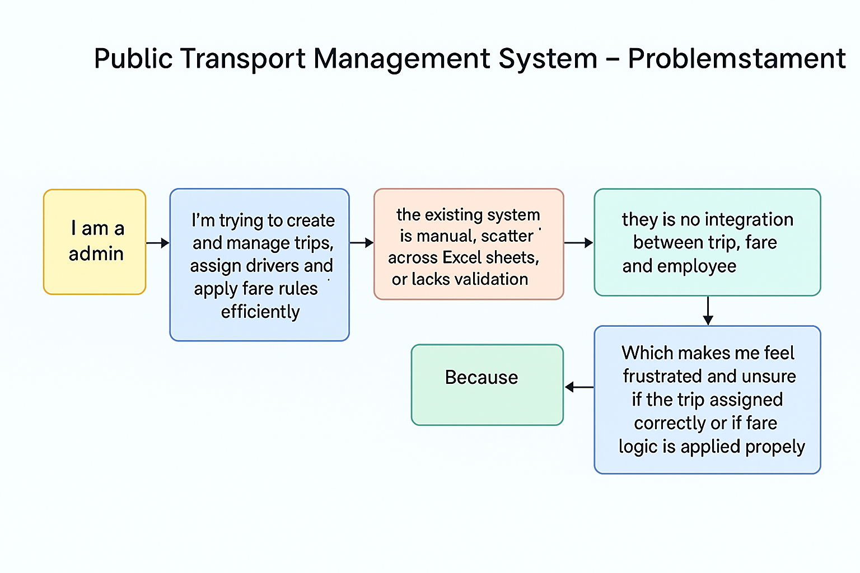

# Brainstorming & Idea Prioritization - Public Transport Management System 📄 Project Name: Public Transport Management System 📅 Date: 22 June 2025 🆔 Team ID: LTVIP2025TMID30999

## Step 1: Select the Problem Statement

## Lack of integration in trip scheduling, fare assignment, and employee role validation.

## Step 2: Idea Listing

* Create custom Salesforce objects for Buses, Trips, Ticket Fares, and Employees
* Use Salesforce Flow to auto-fetch Ticket Fare based on Route_Name__c and Bus_Model__c
* Implement Apex Trigger to validate that only Drivers and Conductors are assigned to trips
* Add summary reports like “Employees by Bus Station” using Report Builder
* Provide dashboards to monitor employee assignments, trip count, and fare logic

## Step 3: Prioritize Ideas

|  |  |
| --- | --- |
| Ideas | Priority |
| Trip & Role Assignment | High |
| Automated Fare Fetching | High |
| Role Validation with Trigger | High |
| Reporting Dashboard | Medium |
| Employee Summary Reports | Medium |